MMKC Board Meeting
Tuesday, October 5, 2021

Agenda
Vice President – Irina
Ideas for next year’s programs – any thought to a knit-a-long of some sort for next year

Treasurer – Gretchen

Website – Elektra

Textile Center
Guild Wall opportunity – the date open to us is March 1 – April 29, 2023!! There was a scheduling miscommunication for 2022. Anyone still interested?

At this time we are still uncertain about meeting there next year – thoughts to continue with Zoom meetings through spring and then re-visit

State Fair
Time to re-visit awards. We pre-pay for the rosettes and 2 were not used this year – we have 3 rosettes at $6.00 each which is not a big deal, but I would like to discuss keeping the monetary award the same, eliminate the rosettes and perhaps add a monetary award to the Senior Machine Knitting lot.
Following are the awards as listed in the Premium Book – there is no award in Senior for machine knitting
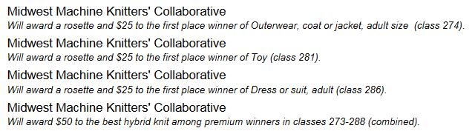
At a later date there may be discussion about a need for clarification for the hybrid award.

